AI-BASED SMART TRAFFIC MANAGEMENT
Conclusion, Future Scope and References
Department of Computer Science and Engineering, TKR College of Engineering & Technology
Batch A10 (CSE-A) · Academic year [ACADEMIC YEAR]
Table 1: Project team
S.No. | Student name | Roll number
1 | Buneti Harshitha | 23K91A0548
2 | Bhuvaneshwari Kadike | 23K91A0537
3 | Ambati Sai Nikhil Reddy | 23K91A0510
4 | Chapala Rohith Reddy | 23K91A0551

Project guide: Laxmi Prasanna
Chapter and section numbers quoted in the text (for example Chapter 8 or Section 6.2) refer to the full project report, 17.Final Document. Figures and tables in this document are numbered from 1.

1. CONCLUSION

1.1 Summary of the work
FlowSense was built to show, in one working product, the chain that the batch abstract describes: detect vehicles, forecast congestion, adapt signal timing, give emergency vehicles priority, coordinate neighbouring junctions and log violations. The product consists of a seeded traffic-network simulator with four signal controllers, a YOLOv8n vision layer with a light-bar rule and a density estimate, a gradient-boosting queue forecaster, a violation log, and a FastAPI and React console. It is grounded in the base paper [1], whose emergency-aware supervisory layer it emulates and extends with forecasting and route-wide coordination.
The work was evaluated, not just demonstrated. Four controllers were compared on identical seeded traffic for five seeds, with a demand sweep, an emergency-heavy test and an ablation; the forecaster was validated by leaving whole simulation runs out; and the vision layer was measured on rendered scenes, on 293 real dashcam frames and on 600 real ambulance and non-ambulance photographs.

1.2 Objectives achieved
Table 2: The eight objectives and their status
Objective | Status | Headline evidence
Vehicle detection and classification with YOLOv8 | Partly achieved | 32 ms per frame on a CPU; real-frame recall 0.586 (4-wheelers), 0.083 (2-wheelers), 0 (3-wheelers)
Dynamic signal timing from density | Achieved in simulation | Delay -34.8 % (2x2), -30.5 % (3x3) against fixed-time
Emergency-vehicle priority | Achieved in simulation; detection not | Ambulance delay -71.5 % and -86.7 % against fixed-time; light-bar recall 0.013 on real photos
Congestion prediction | Partly achieved | MAE 1.64, R2 0.96 (random split); R2 0.04 across held-out runs
Inter-junction coordination | Partly achieved | Implemented in simulation; measured effect small
Violation detection | Partly achieved | Simulated events logged; no detector
Reduce waiting, congestion and fuel | Achieved in simulation | Queue 96.3 to 61.3 veh; idle fuel 28.9 to 18.4 L per run (2x2)
Road safety and efficiency | Not measured | No safety metric exists

1.3 Key findings
1. Adaptivity is what matters for general traffic. Queue-actuated control already removes about a third of the delay of fixed-time signals; the advanced controller adds only 4.3 % (2x2) and 5.3 % (3x3), within one standard deviation, and is worse at low demand.
2. Pre-emption saves ambulance time and costs everyone else a little. Ambulance delay falls by about 70-87 % against fixed-time; the base-paper-style controller is slower than plain adaptive control for general traffic, and without any pre-emption the network is fastest (42.4 s) but ambulances wait 27.3 s.
3. The route-wide green wave helps ambulances most on larger grids. On the 3x3 grid the advanced controller's ambulance delay is 24.9 % below the one-junction pre-emption (5.6 against 7.5 s); on the 2x2 grid the gain is 4.2 %.
4. The forecaster looks better than it is. The random-split R2 of 0.96 collapses to 0.04 when whole runs are held out, because trees cannot extrapolate to unseen congestion; its closed-loop value is about 3 s of delay.
5. Synthetic vision success does not transfer. The light-bar rule found every ambulance in rendered scenes and 4 of 300 in real photographs; the stock detector misses most two-wheelers and all three-wheelers in real mixed traffic. On inspection, the four ambulance photographs the rule flagged were flagged on red and blue livery, a flag graphic and a star-of-life, not on roof lights, so even 4 of 300 overstates it.
6. Evaluation design changes conclusions. The three-seed benchmark screen shows -38 % against fixed-time; five seeds give -34.8 %; the demand sweep shows where the advanced controller is worse; the real-image tests overturn the synthetic ones.

1.4 Practical applications
• A teaching and planning tool for comparing signal strategies on identical traffic before touching a real junction, including how much delay an ambulance green wave costs other traffic.
• A demonstrator of an end-to-end camera-to-signal architecture and a baseline for the next stage: fine-tuned detection, calibrated simulation and hardware-in-the-loop trials.

1.5 Known limitations
The simulator is not SUMO and is uncalibrated; the emergency detector is not trained and fails on real photographs (its few hits were livery colours, not lights); vehicle detection is a stock COCO model that misses two- and three-wheelers; violations are simulated; the advanced controller's benefit over plain adaptive control is small; the forecaster does not generalise to unseen congestion; and nothing was tested with real cameras, signal hardware or many users. These limitations are listed with their evidence in Chapters 8 and 10, and they define the future work below.

1.6 Lessons learned
• Compare against the right baseline. Against fixed-time signals every adaptive idea looks good; the informative comparison is against plain queue-actuated control, and that is where the advanced controller's advantage shrinks to about 4-5 %. A project that reports only the first comparison overstates its contribution.
• Validate the way the system will be used. A random train and test split gave a forecaster R2 of 0.96; holding out whole simulation runs gave 0.04. The first number is what the product screen shows; the second is closer to what an operator would meet on a new, more congested day.
• Do not trust one's own test data. The synthetic scenes were drawn by the same code that detects the vehicles in them, and the detector scored 0.976 recall and 1.000 ambulance recall; on real photographs the same rule scored 0.013. Real images, however few, changed the conclusion about emergency detection.
• Say what is simulated. Violations, plates, confidences and the knowledge of where an ambulance is are all generated inside the simulator. Labelling them as such in the interface, the tests and the documents prevents the demonstration from being read as detection.
• Seeds matter. Five seeds already show that the ordering of fixed-time, adaptive and advanced control is stable, and that the distance between adaptive and advanced is not; three seeds produced the -38 % on the benchmark screen, five give -34.8 %.
• Measure the cost of safety features. Pre-emption was assumed to be nearly free; the base-paper-style controller is slower than plain adaptive control for everyone else, and the ablation shows the network is fastest with no pre-emption at all.

1.7 Concluding remarks
FlowSense demonstrates that a complete, inspectable smart-traffic pipeline can be built, run on an ordinary computer and evaluated on identical traffic: adaptive control removes about a third of the delay of fixed-time signals, ambulance delay can be cut by about three quarters or more when the signals look ahead for them, and a forecast and a coordinated look-ahead add a smaller, measurable benefit. It also shows, with numbers, where such a project is weak: the perception components were not trained for the task and do not hold up on real photographs, the simulator is not calibrated, and the violation module is a simulation of enforcement. The honest reading of the work is therefore a validated control framework with a working console and a clear list of what must be replaced by real data, a trained emergency detector and field calibration before any claim about real roads could be made.
The results behind the key findings are shown below: how the four controllers compare on identical traffic, and how the relative gains sit next to the figures reported in the base paper (different testbeds, so indicative only).
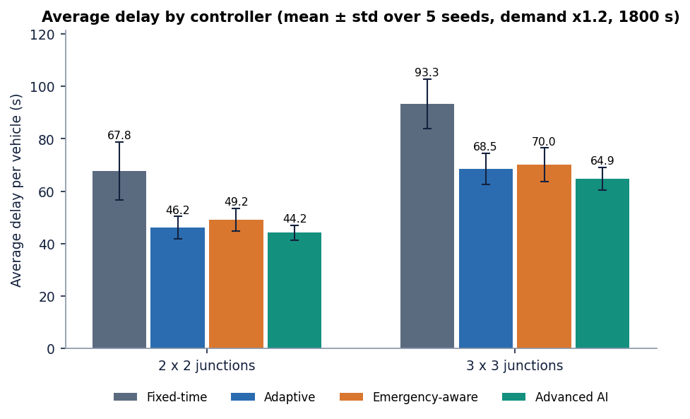
Figure 1: Average delay per vehicle for the four controllers on the 2x2 and 3x3 networks (5 seeds, mean and standard deviation).
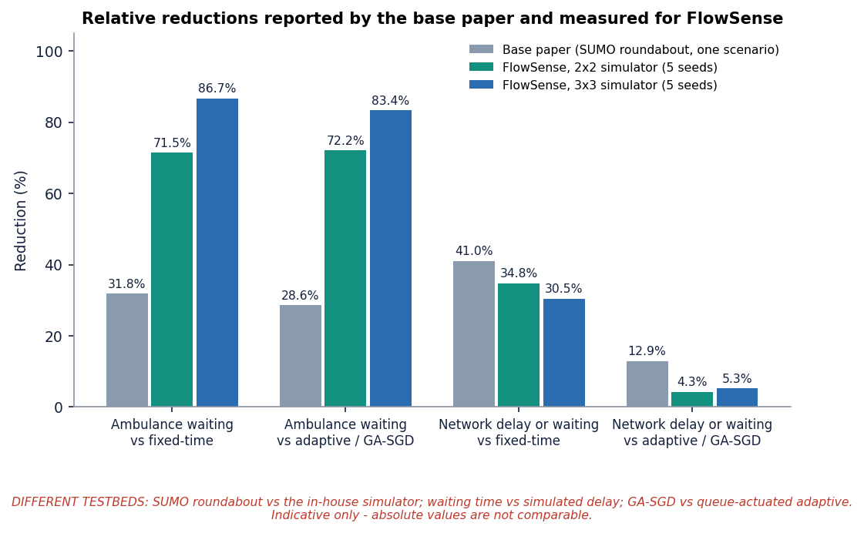
Figure 2: Relative reductions reported in the base paper (SUMO roundabout) next to those measured here (FlowSense simulator): different testbeds, indicative only.

2. FUTURE SCOPE

2.1 Improvements to the existing system
1. Train a dedicated emergency detector. Fine-tune YOLO on a light-bar or emergency-vehicle data set (the base paper's 3,130-image approach, or public siren and ambulance data), evaluate precision, recall and mAP, and replace the HSV rule. The target is the base paper's precision 0.73, recall 0.69 and mAP50 0.73, measured on real photographs rather than rendered scenes.
2. Fine-tune vehicle detection on local traffic. Fine-tune on mixed-traffic data with a 3-wheeler class (such as the 293-frame set used in Chapter 8, extended) and measure the gain over the stock model's recall of 0.083 for two-wheelers and 0 for three-wheelers.
3. Close the loop. Feed the detector's confirmed detections (a confidence threshold with a short temporal confirmation window, as in the base paper) and the PCU density into the controller instead of ground-truth knowledge in the simulator.
4. Make the forecaster robust. Train on a wider range of demand including heavily congested runs, use models that extrapolate (linear trend terms, sequence models), report leave-one-run-out validation by default, and choose the forecast weight by demand level so that the advanced controller does not lose to adaptive control at low demand.
5. Tune and justify the controller constants (0.7, 8 s, 12 s, 0.3, minimum and maximum green) by systematic search on one set of seeds and testing on another, and compare against max-pressure control and learned policies [26], [27].

2.2 Additional features
• Multi-phase signals with protected turns, pedestrian phases and bus priority, and a signal-timing output that respects local standards.
• Real violation detection: red-light and wrong-way detection from video with tracking and number-plate recognition, evaluated on labelled clips, replacing the simulated log.
• Persistence and roles: a database for events and configurations, operator and administrator roles, audit logging.
• Alerting and reports: scheduled benchmark reports, exportable evidence packs, notifications when a junction is pre-empted.
• More emergency cues: siren audio and flashing-state analysis to complement the light-bar, as suggested by the base paper's own limitations.

2.3 Scalability and deployment
• SUMO and TraCI port. Re-implement the controllers against SUMO, calibrate against counts from a real corridor, and compare directly with the base paper's roundabout study [1].
• Camera ingestion. RTSP or file ingestion with frame sampling, batching and a bounded queue; one detector process per camera or a shared GPU worker.
• Edge deployment. Export the detector (ONNX or TensorRT), measure latency on an embedded GPU, and keep the forecaster and controller on a small controller box; the base paper's 11-14 ms was on a GPU, ours is about 32-51 ms on a CPU.
• Distributed coordination. Replace look-ahead on a shared simulation state with messages between junction controllers (V2I or a publish-subscribe link), and test with delayed and lost messages.
• Operations. Containerise the API and console, add health probes and metrics, run load tests with many operators, and replace the demo token with a standard identity provider.

2.4 Further research
• Compare the advanced pressure rule with reinforcement-learning controllers [27] and with graph-neural-network traffic models such as the archived second candidate base paper [7] on the same benchmark.
• Study the efficiency-safety trade-off of pre-emption formally: how many seconds of general delay is an ambulance second worth, as a function of demand and grid size.
• Evaluate the accuracy of detectors trained on synthetic scenes when transferred to real cameras, and whether realistic rendering closes the gap measured here.
• Quantify fuel and emissions with a proper emissions model instead of an idling-rate assumption, and add safety surrogate measures such as time-to-collision.

2.5 Proposed roadmap
The improvements above are ordered below so that each stage removes a limitation measured in Chapter 8 and has a success measure that can be checked with the scripts already in the repository.
Table 3: Roadmap from the present system to a field-ready study
Stage | Work | Limitation removed | Success measure
1. Perception | Fine-tune YOLO on a local mixed-traffic set with a 3-wheeler class; train a light-bar or emergency-vehicle detector on real photographs | Stock detector (2-wheeler recall 0.083, 3-wheeler 0.000); light-bar rule recall 0.013 | Precision, recall and mAP50 on a held-out real set at or above the base paper's 0.73 / 0.69 / 0.73 for the emergency class; vehicle recall for 2- and 3-wheelers above 0.5
2. Closed loop | Feed detections and PCU density into the controllers with a temporal-confirmation rule; remove ground-truth knowledge of ambulances | Ground-truth emergency knowledge | Ambulance delay with detected (not known) ambulances within 20 % of the ground-truth case in the benchmark
3. Robust forecasting | Wider training demand, extrapolating models, leave-one-run-out reporting, demand-dependent forecast weight | Held-out R2 0.04; worse than adaptive at low demand | Held-out MAE below persistence on every fold; advanced controller no worse than adaptive at x0.6
4. Calibrated simulation | Port to SUMO/TraCI, calibrate with counts from a real corridor, add pedestrian and turn phases | Uncalibrated, two-phase simulator | Simulated flows within an agreed tolerance of counted flows; results repeated in SUMO
5. Real data pipeline | RTSP ingestion, tracking, number-plate recognition on labelled clips, persistence and roles | Simulated violations; demo login; in-memory state | Violation detector precision and recall on labelled clips; audit log of every event
6. Pilot | Edge deployment and hardware-in-the-loop on a single junction with the authority's approval | No hardware tests | Detector latency and signal-command latency measured on the device; safe fall-back to fixed-time verified

Stages 1 to 3 can be completed on the existing code base and a workstation; stages 4 to 6 need field data, traffic-authority cooperation and hardware, and should not be started before the first three show that the perception and forecasting components hold up on real data.

3. REFERENCES
[1] M. Lamrabet, M. Alami Chentoufi and R. Ellaia, "Emergency-aware adaptive traffic signal control using YOLO-based light-bar detection and SUMO system-level validation," IEEE Access, vol. 14, pp. 104922-104933, 2026, doi: 10.1109/ACCESS.2026.3710015.
[2] "Signal-IQ: an integrated, low-cost, and hardware-validated adaptive traffic signal control system using YOLOv8-based vehicle and emergency-vehicle detection," 2026 (as listed in the batch literature survey; authors and venue not verified).
[3] "Adaptive traffic signal control system for vehicle detection and traffic density estimation," in Proc. 4th Int. Conf. Innovative Sustainable Computational Technologies (CISCT), 2024 (as listed in the batch literature survey; authors not verified).
[4] "Accelerated emergency vehicle detection and intelligent traffic signal control," in Proc. Int. Conf. Information, Implementation, and Innovation in Technology (I2ITCON), 2025 (as listed in the batch literature survey; authors not verified).
[5] "Intelligent traffic management system using real-time vehicle detection and dynamic signal control with client-server architecture," in Proc. Int. Conf. Next Generation Communication & Information Processing (INCIP), 2025 (as listed in the batch literature survey; authors not verified).
[6] C. R. Goenawan, "ASTM: Autonomous smart traffic management system using artificial intelligence CNN and LSTM," arXiv:2410.10929, 2024.
[7] K. Gupta, D. Saxena, A. K. Singh and C.-N. Lee, "Neighbor-embedded graph neural network-based crowd delivery traffic management in smart city," IEEE Trans. Emerg. Topics Comput. Intell., vol. 10, no. 3, 2026, arXiv:2608.22555.
[8] M. Lamrabet, R. Ellaia and M. Alami Chentoufi, "Simulation-based optimization of traffic signals using a hybrid GA-SGD approach: a case study of Morocco," Innov. Infrastruct. Solutions, vol. 10, no. 11, p. 511, Nov. 2025, doi: 10.1007/s41062-025-02319-w.
[9] N. Sasikala, S. Sridhar, S. H. Reddy, S. John and S. Shrinikethan, "Emergency traffic prioritization system with priority-based dynamic route optimization and IoT-enabled dynamic signal control," in Proc. 5th Int. Conf. Intell. Technol. (CONIT), Jun. 2025, pp. 1-5, doi: 10.1109/CONIT65521.2025.11166819.
[10] M. Zlatkovic, Z. Cvijovic, A. Stevanovic and Y. Song, "Concepts of signal control preemption for emergency vehicles in connected vehicle environments," J. Road Traffic Eng., vol. 69, no. 2, pp. 1-7, Jun. 2023, doi: 10.31075/pis.69.02.01.
[11] V. Prajwal, I. Rahul, S. A. A and M. Chayadevi, "Increasing emergency response time: a smart GPS and IoT-based approach for ambulance optimization," in Proc. 2nd Int. Conf. Adv. Inf. Technol. (ICAIT), Jul. 2024, pp. 1-5, doi: 10.1109/ICAIT61638.2024.10690489.
[12] A. Chowdhury, S. Kaisar, M. E. Khoda, R. Naha, M. A. Khoshkholghi and M. Aiash, "IoT-based emergency vehicle services in intelligent transportation system," Sensors, vol. 23, no. 11, p. 5324, Jun. 2023, doi: 10.3390/s23115324.
[13] M. Giordano, S. Giacomelli, C. Rinaldi and F. Graziosi, "Real-time emergency vehicle siren detection with efficient CNNs on embedded hardware," arXiv:2507.01563, 2025.
[14] D. Jayakumar, M. Krishnaiah, S. Kollem, S. Peddakrishna, N. Chandrasekhar and M. Thirupathi, "Emergency vehicle classification using combined temporal and spectral audio features with machine learning algorithms," Electronics, vol. 13, no. 19, p. 3873, Sep. 2024, doi: 10.3390/electronics13193873.
[15] T. V. Phuong, C. Tran, T. Vo, K.-D. Nguyen and N. D. Vo, "Real-time vehicle detection using surveillance cameras: an empirical evaluation in Vietnamese traffic scenes," in Proc. 13th Int. Conf. Control, Autom. Inf. Sci. (ICCAIS), Nov. 2024, pp. 1-6, doi: 10.1109/ICCAIS63750.2024.10814528.
[16] B. Khalili and A. W. Smyth, "SOD-YOLOv8 - enhancing YOLOv8 for small object detection in traffic scenes," arXiv:2408.04786, 2024.
[17] S. A. Fahim, "Finetuning YOLOv9 for vehicle detection: deep learning for intelligent transportation systems in Dhaka, Bangladesh," arXiv:2410.08230, 2024.
[18] S. Suhana, B. Prathap Rudra, K. Narang and I. Anto, "IoT based emergency vehicle detection using YOLOv8," J. Autom., Mobile Robot. Intell. Syst., vol. 19, no. 2, pp. 79-88, Jun. 2025, doi: 10.14313/jamris-2025-018.x.
[19] K. N. V. Satyanarayana, R. G. Prasanna, R. R. K. S. Satwik, P. Rupchand, P. Srihaas and S. Bhuvanapriya, "Smart traffic management for emergency vehicles using YOLOv8 algorithm," in Advances in Computational Intelligence and Robotics, Hershey, PA, USA: IGI Global, 2025, pp. 491-510, doi: 10.4018/979-8-3693-9375-8.ch029.
[20] V. Sharma, A. A. Shah and M. Makwana, "Traffic categorization with emergency vehicle identification using YOLOv5," in Proc. 8th Int. Conf. Comput. Methodologies Commun. (ICCMC), Jul. 2025, pp. 1779-1784, doi: 10.1109/ICCMC65190.2025.11140676.
[21] J. Redmon, S. Divvala, R. Girshick and A. Farhadi, "You only look once: unified, real-time object detection," in Proc. IEEE Conf. Comput. Vis. Pattern Recognit. (CVPR), Las Vegas, NV, USA, Jun. 2016, pp. 779-788, doi: 10.1109/CVPR.2016.91.
[22] G. Jocher, A. Chaurasia and J. Qiu, "Ultralytics YOLOv8," version 8.0.0, 2023. [Online]. Available: https://github.com/ultralytics/ultralytics
[23] T.-Y. Lin et al., "Microsoft COCO: common objects in context," in Computer Vision - ECCV 2014, Lecture Notes in Computer Science, Springer, 2014, pp. 740-755, doi: 10.1007/978-3-319-10602-1_48.
[24] P. A. Lopez et al., "Microscopic traffic simulation using SUMO," in Proc. 21st IEEE Int. Conf. Intell. Transp. Syst. (ITSC), Maui, HI, USA, Nov. 2018, pp. 2575-2582, doi: 10.1109/ITSC.2018.8569938.
[25] F. V. Webster, "Traffic signal settings," Road Research Technical Paper No. 39, Road Research Laboratory, HMSO, London, U.K., 1958.
[26] P. Varaiya, "Max pressure control of a network of signalized intersections," Transp. Res. C, Emerg. Technol., vol. 36, pp. 177-195, Nov. 2013, doi: 10.1016/j.trc.2013.08.014.
[27] H. Wei, G. Zheng, H. Yao and Z. Li, "IntelliLight: a reinforcement learning approach for intelligent traffic light control," in Proc. 24th ACM SIGKDD Int. Conf. Knowl. Discovery Data Mining, London, U.K., Jul. 2018, pp. 2496-2505, doi: 10.1145/3219819.3220096.
[28] J. H. Friedman, "Greedy function approximation: a gradient boosting machine," Ann. Statist., vol. 29, no. 5, pp. 1189-1232, Oct. 2001, doi: 10.1214/aos/1013203451.
[29] L. Breiman, "Random forests," Mach. Learn., vol. 45, no. 1, pp. 5-32, Oct. 2001, doi: 10.1023/A:1010933404324.
[30] F. Pedregosa et al., "Scikit-learn: machine learning in Python," J. Mach. Learn. Res., vol. 12, pp. 2825-2830, 2011.
[31] Transportation Research Board, Highway Capacity Manual: A Guide for Multimodal Mobility Analysis, 6th ed. Washington, DC, USA: National Academies Press, 2016.
[32] Visaitech, "Visaitech mixed-traffic vehicle detection dataset (v0.1)," Hugging Face, CC BY 4.0. [Online]. Available: https://huggingface.co/datasets/visaitech/vehicle-mixed-traffic-detection
[33] shravya11, "Ambulance classification dataset (ambulance / no-ambulance images)," Hugging Face, CC BY 4.0. [Online]. Available: https://huggingface.co/datasets/shravya11/ambulance-images

